To Run this code, fallow the following guidelines:

1. Open the project in Visual Studio.
2. Import it from where you have downloaded it.
3. The .mdf file is attached with the code.
4. First Check if it is imported with the project or not .
5. If it is not imported kindly import it from the file.

After Import check the following:

1. Open the Server Explorer as fallow:

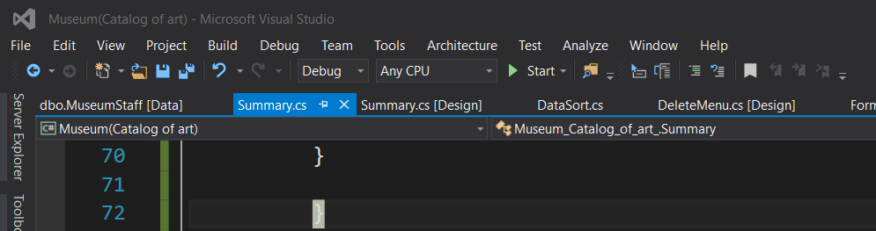

Click on view and open the Server Explorer

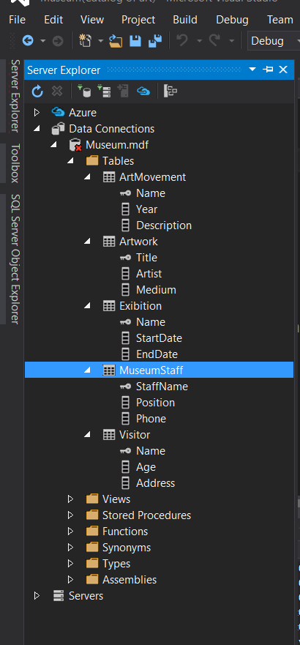

In server explorer the database automatically will be shown .

1. Click on the database

Copy the connection string from the below corner

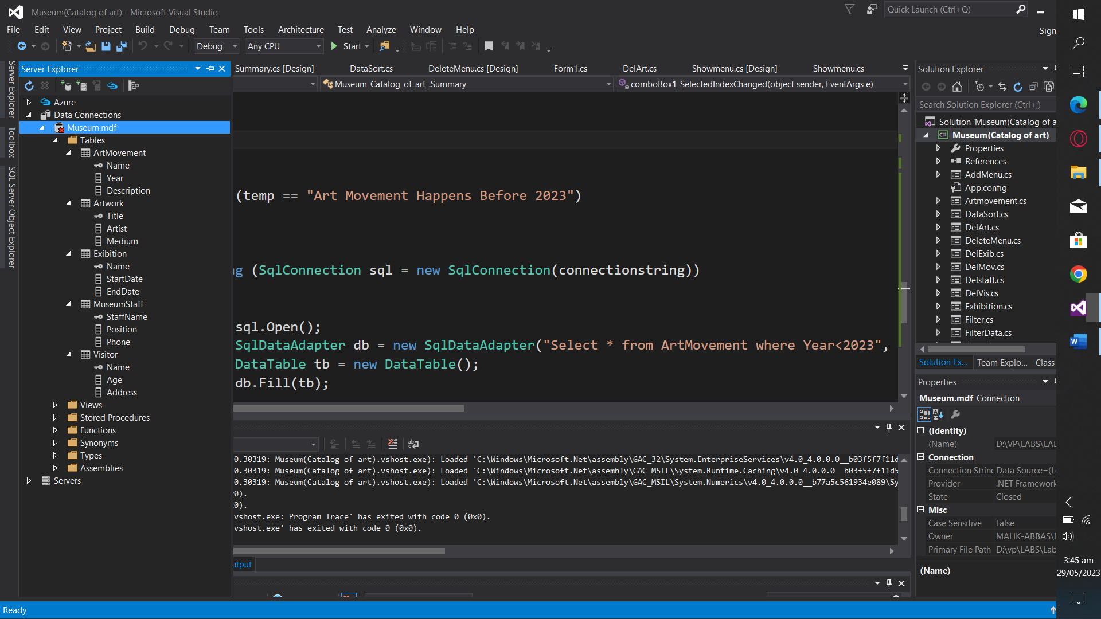



1. Copy that

And paste it every where in the code where connection string is used your code will run smoothly

For Further Assistance you can contact me: